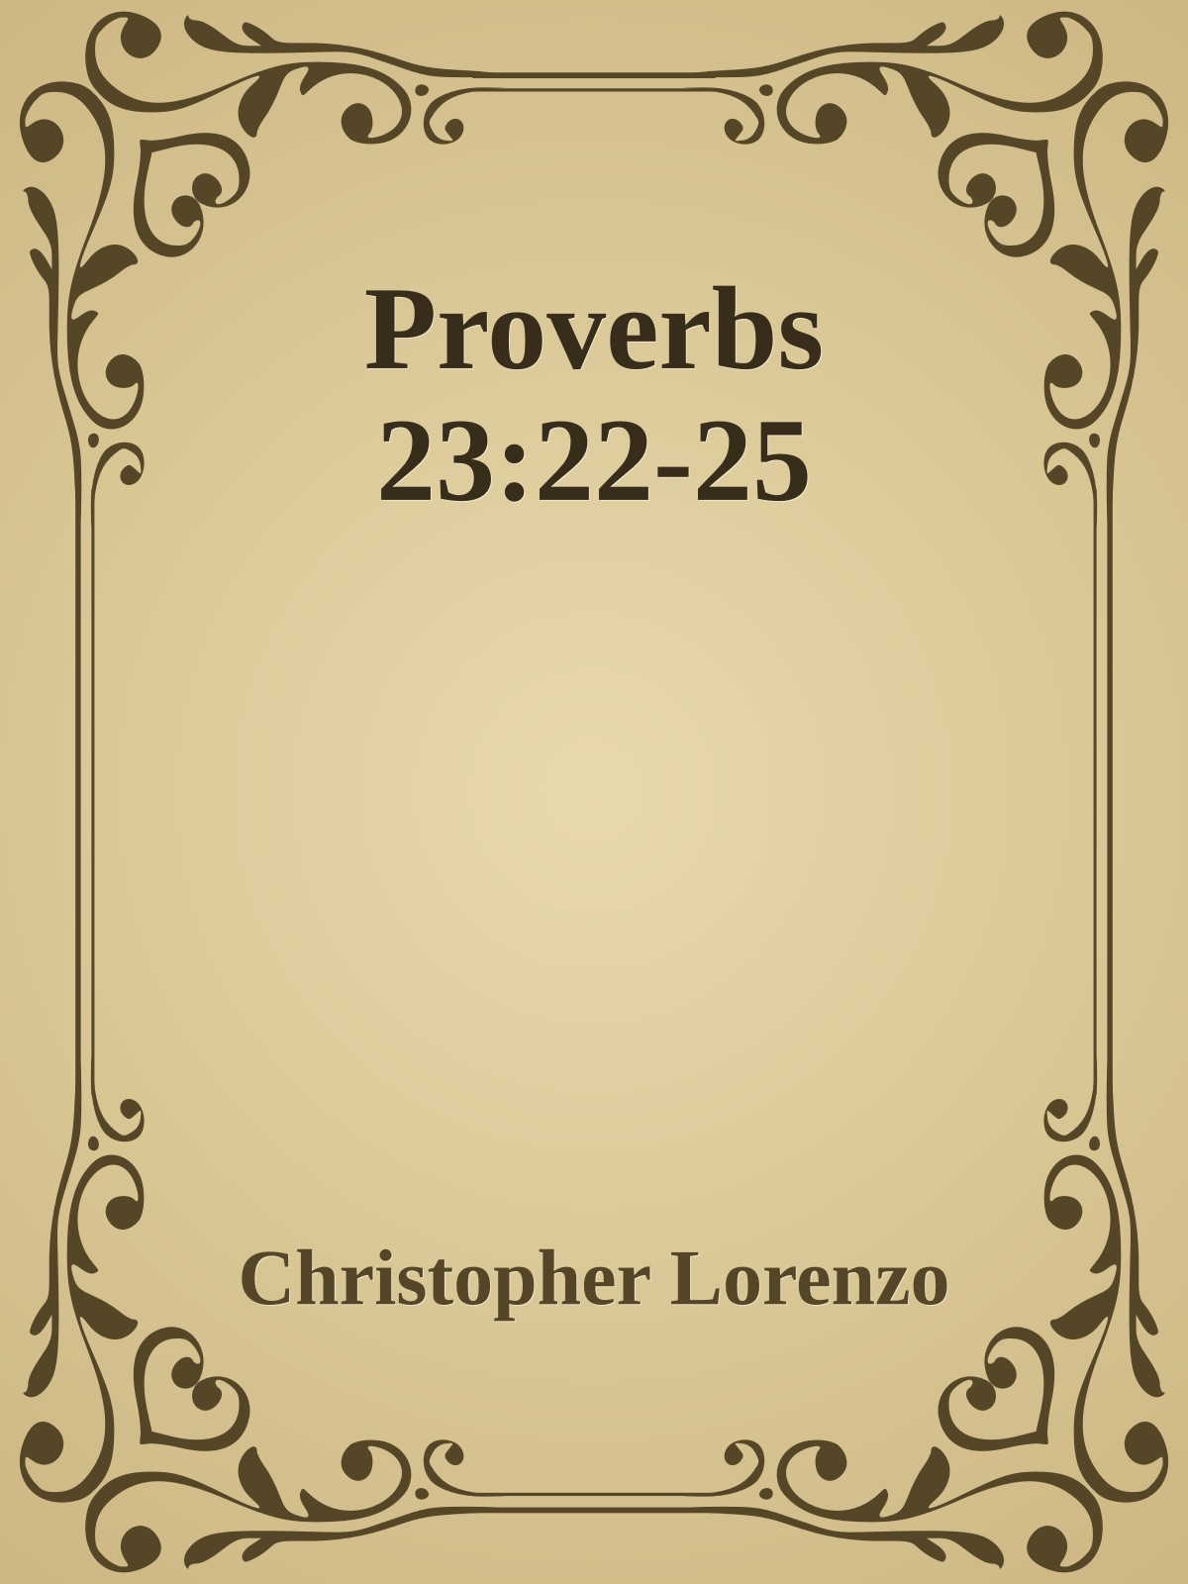

Proverbs 23:22-25

22. Listen to your father, who gave you life, and don’t despise your mother when she is old. 23. Get the truth and never sell it; also get wisdom, discipline, and good judgment.

24. The father of Godly children has cause for joy. What a pleasure to have children who are wise. 25. So give your father and mother joy! May she who gave you birth be happy.

Proverbs 22 and Proverbs 23 have a couple of really famous sayings that are used in society today…or at least they used to be. Sayings like Train your child up the way he should go and the truth will never depart him, or Spare the rod, spoil the child are two of the most famous of Solomon’s proverbs and for good reason. Anyone who has ever had or raised children knows the importance of discipline and also we know the importance of teaching them about Jesus.

Today’s proverbs is neither of those but has to do with both of them. It still amazes me that all scripture is intertwined with each other. I found out a long time ago that if it is important or needs beat into us sheep on a daily basis, God will say it multiple times. This devotion is more than just to our children, it is to each of us who are children of God. Knowledge and Wisdom are things that can never be taken from us by someone, it can only come at a loss with time or disease, but we can never lose it to someone. Wealth can be stolen, goods can be ruined, life can be taken, but Wisdom of the Lord and Knowledge of Jesus as Lord will stay with you for eternity.

As people we all want to find some greater truth, the why’s and the reasons things happen to us and our loved ones, but God sometimes does not give us the why’s, but He always gives us the joy and peace of a comforting hand that only a parent can give. As Children of the Most High God, we are special, we are chosen and we are redeemed by the blood of the Lamb this morning and every morning for eternity. All of us will one day be around the throne of God saying Holy, Holy, Holy is the Lord God Almighty. We will all stand before His throne and cast our crowns to Him.

Remember this week to remember the instruction that the Word of God, our bibles, gives us and praise Christ daily. Shout His name from the treetops and say them in the alleyways. If we fail to do so, just remember the rocks will cry out in our place. And as always keep all of us here at New Life in your prayers. Classes May Take Their Place